GUIDELINES FOR PREPARING A CONFERENCE ABSTRACT (MAX 1 PAGE) FOR THE IFESS CONFERENCE
Author A¹, Author B², Author C¹, Author D², Author E³
¹Institute, University, Country
²Clinic, University, ….
³Company, City, ….
e-mail@corresponding.author

Introduction: Please present the content of your contribution using between 400 and 500 words, font size 10 pt, with single line spacing using a structured text starting with the rationale for the contribution [1]. The word count is exclusive figures, tables, acknowledgments, and references.
Methods: A description of the methods and materials used [2] should follow.
Results: Then, the results are presented. It is strongly recommended to include a graphical abstract (Fig. 1), with the caption as a footer. You may also include one representative Table (Tab. 1) with the caption as a headline. In case the caption consists only of a single line, it should be centered (e.g., Fig. 1), otherwise, it must be left and right justified (e.g., Tab. 1). Please notice that – in contrast to the figure – in the table, only alphanumerical characters (i.e., no graphical elements) are allowed. The proper formatting of the different text items is given in Tab. 1.
Discussion and conclusion: Finalize the description discussing the findings/methods and stating a conclusion.

References should be enumerated with Arabic numerals in square brackets in the order of their first occurrence in the text, and placed in the section ”References” at the end of the manuscript.

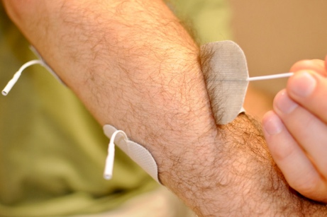
Figure 1: Removal of adhesive electrodes.
Table 1: Fonts and –sizes used in different sections of the manuscript.
item | font size | style | paragraph spacing
Title | 14 | Capital letters, bold | 12 pt
Author/Institute/e-mail | 11 | Body text | 6 pt
Headline | 11 | Headline 2 | 6 pt
Text | 10 | Body text | single
Letterings | 10 | Body text
Equations | 10

Acknowledgments: In case acknowledgments are to be given, this paragraph must be placed before the bibliography.

References
- P. Muster , Title , Berlin: Springer, 1999.
- Muster, A., Muster, P. et. al.: Title, Journal, vol. 50, pp. 324-333, April 2010

Please make sure not to exceed one page.

